|  |
| --- |
| Kauz Informatik | Medien AG |
| TackPad |
| An easy to do list application |

|  |
| --- |
| Luethy Olivier  31.8.2021 |

Table of contents

1. Introduction 2

2. Job description 2

3. Database structure 2

4. User Story’s 4

5. List of figures 5

# Introduction

Every person has tasks to do, but not everyone can remember them. Often, they must write them somewhere and then find those again. This application makes the to do system much easier by using only this app.

# Job description

This project didn’t come from the boss or a client. I gave this project to myself. Once I didn’t know on what I should work for. Then I heard that a lot of people are building up to do list applications. Then a idea felt Infront of my eyes: Making a good or useful, clean and easy made to do list application.

In this application you should add tasks. Every task has his own title and task description. Afterword’s, when the task has been completed you should mark it as completed. Very simple right?

# Database structure

Down below you can find the database structure used for this project:

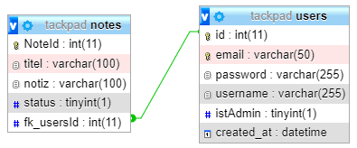

Figure 1: Database structure

# Use Case Diagram

Down below you can find a picture which displays the use case diagram of this project:

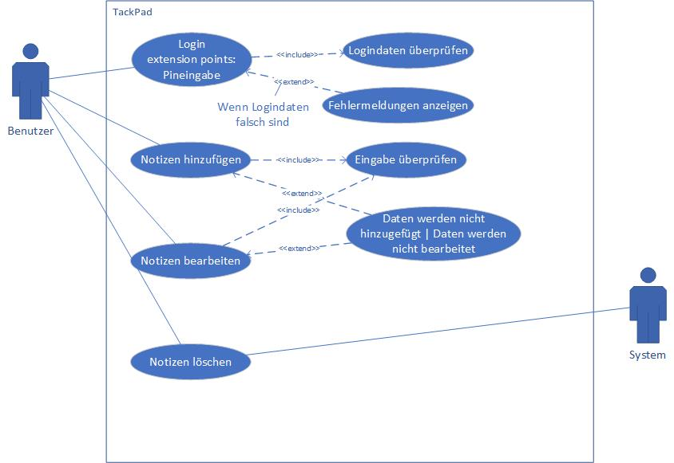

Figure 2: Use Case Diagram

Below you can find the sql script used for the database:



Figure 3: SQL Script used for database

# User Story’s

Here you can find all the user stories for this project:

|  |  |
| --- | --- |
| User Story 1 |  |
| Title | Add notice |
| Story | As a logged in user, I can add a task to the website, so I can see it. |
| Effort | 15min |
| Priority | 1 |

|  |  |
| --- | --- |
| User Story 2 |  |
| Title | Edit notice |
| Story | As a logged in user, I can edit a task from the website, so I can actualise it. |
| Effort | 20min |
| Priority | 1 |

|  |  |
| --- | --- |
| User Story 3 |  |
| Title | Delete notice |
| Story | As a logged in user, I can delete a task from the website, so it won’t appear on the website. |
| Effort | 20min |
| Priority | 1 |

|  |  |
| --- | --- |
| User Story 4 |  |
| Title | Login |
| Story | As an unlogged in user, I can log me in, so I can see my tasks which I added before. |
| Effort | 20min |
| Priority | 1 |

|  |  |
| --- | --- |
| User Story 5 |  |
| Title | Register |
| Story | As an unregistered user, I want to register me, so that I can log me in. |
| Effort | 20min |
| Priority | 1 |

|  |  |
| --- | --- |
| User Story 6 |  |
| Title | Logout |
| Story | As a logged in user, I can log me out, so that I can secure my account. |
| Effort | 20min |
| Priority | 1 |

# List of figures

Figure 1: Database structure 2

Figure 2: SQL Script used for database 3

# Bibliography

|  |  |  |
| --- | --- | --- |
| **Quelle** | **Abgerufen am** | **Beschreibung** |
|  |  |  |
|  |  |  |
|  |  |  |
|  |  |  |